**LITERATURE REVIEW**

**Information Delivery Manual (IDM)**

*Business use case*

A *use case* is defined as a scenario within the life cycle of project in which data exchange is required to enable relevant stakeholders to be able finish their jobs (C. Eastman et al., 2009). The key elements of a use case are: tasks to be completed, actors (project stakeholders), and data exchange requirements which specify what data to be transferred to enable the completion of the works. Some examples of use cases are *“the data exchange between architects, structural engineers and HVAC engineers to develop an as-designed model”*, “*the data exchange between engineers and cost estimators to support quantity take-off and cost estimation”*, or *“the sharing of the design models to the energy analysis process”.* The identification of business use cases is the first step in developing the IDMs for a given type of asset. For each of the identified use cases, an IDM is needed. Since a construction project involves an extensive number of phases and processes, business use cases are usually prioritized and the top ones will be developed first.

*What is IDM?*

IDM aims to capture the industry knowledge and experience about the workflow and information sharing flow of a business use case within the life cycle of a building project. IDM identifies which and when data and information is needed to be transferred from one stakeholder to another. Specifically, the major goals of the IDM are to:

* Identify and describe the processes in which data sharing is required;
* Identify the data producer and receiver for each data sharing scenario;
* Document the specific data requirements for a data sharing scenario.

The core components of an IDM include:

* A process map which explains the sequence of activities to be completed and the actors (stakeholders) involved in the process; and
* Exchange requirements (ER) which specify what data entities/attributes to be transferred to whom and by whom.

*IDM development methodology*

In order to support the formal documentation of IDMs, buildingSMART develops a guide on IDM development methodology which has become the ISO 29481-1:2010 standard and a part of the National BIM standard (National Institute of Building Sciences, 2007). Specifically, developing an IDM consists of the following major stages.

1. Define the scope of the IDM which clearly describes what specific use case in the life cycle of a project (e.g., creating design models, project handover, etc.) to be investigated. The project life-cycle involves a huge number of business processes from the programming to demolishing phases, the most prioritized IDMs will be identified and developed first.
2. Form a workgroup with the involvement of appropriate industry professionals who have background and experience relevant to the scope of the IDM. The members in the workgroup will discuss to identify what activities, actors and the information sharing events that are needed to enable the completion of the identified business use case.
3. Develop a process map based on the discussion in the workgroup. A process map representing the current practice or a proposed business process will be developed to describe the sequence of work and who perform the activities in the workflow. The process map also locates where data exchange will occur and the level of detail needed. The process map is modeled using the Business Process Modelling Notation (BPMN) which can allow for visualization and support application development. Along with the BPMN graph, the map will also be described in plain English for the end user.
4. Create data exchange requirement (ER) for each of the data sharing scenarios identified in the process map. An ER consists of the following information: (1) who is requesting the information, (2) why the activity is happening, (3) when at what phase project execution is, (4) what data (entities, objects, and properties) is needed, (5) to whom the request is being given, (6) how generally the resources (e.g., computer systems, equipment, etc.) are used for a specific activity, and (7) inputs and outcome data. An exchange requirement is shown as ‘message driven event’ in the MPMN process map.
5. Develop a software application to facilitate the implementation of IDM. This stage aims to identify what applications support each of the work in the workflow and map the identified data in the ER to the entities/attributes in the software application.

*IDM development status*

IDM has attracted tremendous attention worldwide. According to a review of the existing efforts, there are more than 30 separate IDM projects have been developed or in progress for various business processes within the life cycle of a building project. Some examples of the approved IDMs include Construction Operations Building Information Exchange (Cobie) standard, IDM for precast concrete standard, etc.

The top prioritized IDMs identified by buildingSMART include:

* Performing energy analysis in the feasibility phase;
* Creation of architectural, structural, electrical and HVAC BIM models in the design phase;
* Perform quantity take-off and cost analysis during coordinated design and procurement stage;
* Develop facility management during coordinated design and procurement stage;
* Perform consistency control during coordinated design and procurement stage.

**IDM for precast concrete (****C Eastman et al., 2009****)**

*IDM scope*

This IDM focuses on the data exchanges between architects, engineers, general contractors and precast fabricators from the programming to fabrication phase.

*Process map*

This IDM divides the life cycle of an architectural precast project into two phases that are pre-construction and fabrication and erection phases. Figure 1 shows the formal BPMN process map of the pre-construction workflow. As shown in the figure, the key information of this process map are as follows.

* Project phases (the heading row). The pre-construction phase include 4 sub-phases that are preliminary project description, design development, construction documentation and procurement.
* 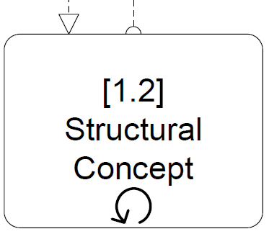 Tasks. There are 11 tasks are needed to be completed, including: [1.1] Concept design of precast facade, [1.2] structural concept, [1.3] Design review and concept modeling, [1.4] design development, [1.5] engineering requirements, [1.6] precast bid preparation, [1.7] GC bid preparation, [1.8] precast detailing, [1.9] design intent validation, [1.10] structural design review, [1.11] construction coordination. The written description of the first task is shown in Figure 2. The sequence of tasks is represented by the solid arrows.
* Actors (the left column). Architect, engineer, product vendor and general contractor are four project stakeholders involved in the process.
* The information exchange scenarios are represented by the dash arrows going from the producer to the receiver.
* 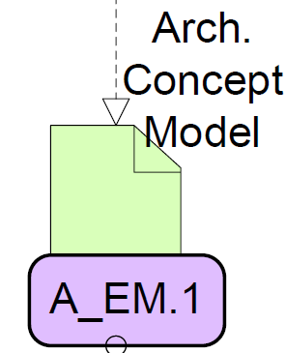Information exchange requirements. There are ten information exchange scenarios are identified among the project actors within the business use case. For instance, the ‘Architecture concept model - A_EM.1’ is required to be transferred from task [1.1] performed by the architect to task [1.2] by the engineer. Theses ERs are described in plain English (see an example in Figure 3) to explain what disciplines involves and generic required information.

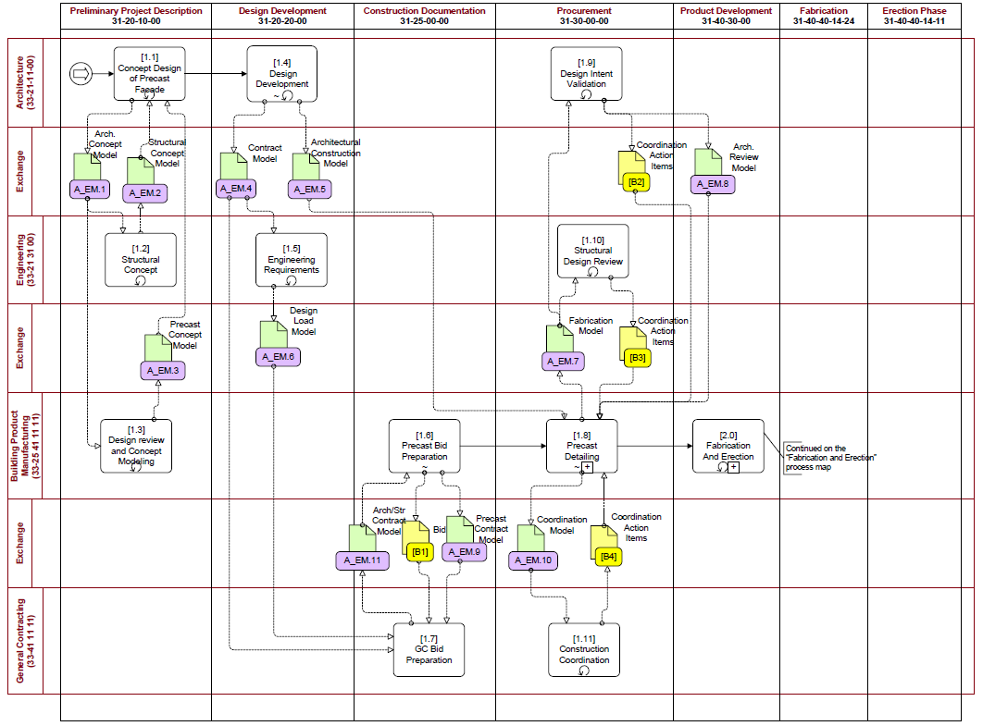

Figure 1. Process map of the pre-construction phase

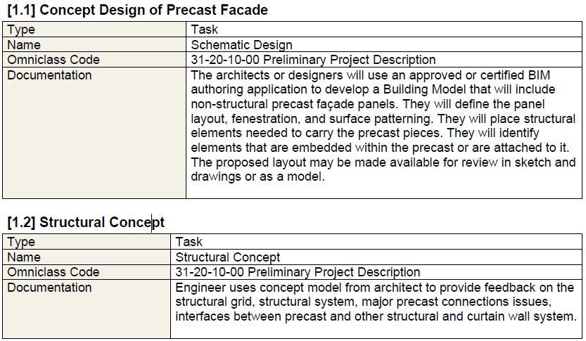

Figure 2. Excerpts of the task descriptions

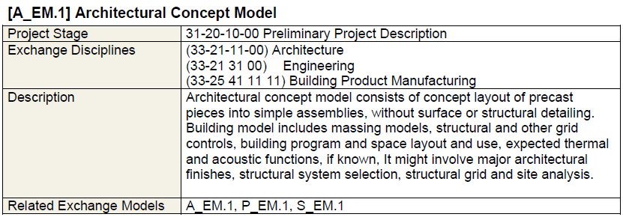

Figure 3. Excerpts of the ER descriptions

*Specifications of the Exchange Requirements (ERs)*

Figure 4 shows a portion of the ER specifications which clearly describe the required and optional data entities and attributes for the corresponding ERs in the process map. The ER specifications are presented as a two-dimensional matrix. The columns (with no color) in the left side list all the data entities and attributes generated throughout the identified workflow, and the heading row of the colored area shows the exchange scenarios. The values of the cells intersecting between an attribute row and an ER column represents the necessity and accuracy of the data attribute in the corresponding exchange requirement. For example, the A_EM.1 exchange dataset (the first ER column in Figure 3) must include the following data attributes: ‘user occupancy’, ‘Located on site’, ‘systems’, etc.

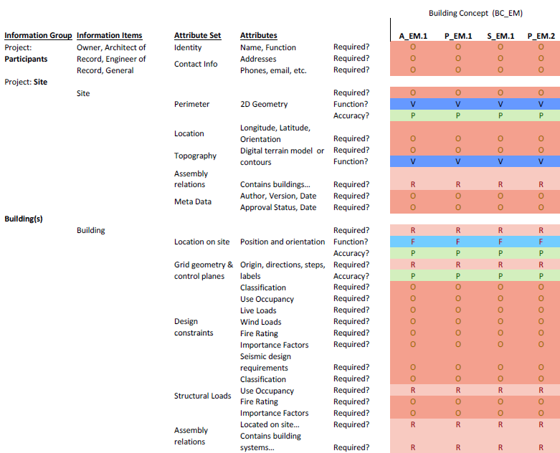

Figure 4. Data entities and attributes of the ERs  
 (notes: ‘O’ and ‘R’ denote ‘optional’ and ‘required’; ‘P’, “C” are ‘planar’ and ‘curved’)

**References**

Eastman, C., Jeong, Y., Sacks, R., & Kaner, I. (2009). Exchange Model and Exchange Object Concepts for Implementation of National BIM Standards. *Journal of Computing in Civil Engineering, 24*(1), 25-34. doi: 10.1061/(ASCE)0887-3801(2010)24:1(25)

Eastman, C., Sacks, R., Panushev, I., Aram, V., & Yagmur, E. (2009). Information delivery manual for precast concrete. *PCI-Charles Pankow Foundation.* [*http://dcom*](http://dcom)*. arch. gatech. edu/pcibim/documents/IDM_for_Precast. pdf (last accessed on 6/20/2010)*.

National Institute of Building Sciences. (2007). United States National Builing Information Modeling Standard- Version 1 - Part 1: Overview, Principles, and Methodologies.